**Software Requirement Specification Document**

**ONLINE MOBILE SHOP**

1. **Introduction:**

The software requirement specification is a document that describes the external requirement for any system. The requirement analyst has to identify the requirements by talking to the clients and understanding and responding to their needs.

The requirement phase translates the ideas of clients into a formal document. The inputs are gathered from different resources. Input given by the clients may not be consistency. It might change according to the modern requirements.

1. **Overview:**

The project entitled “Online Mobile Shop” enables customer to buy mobiles or accessories from anywhere through online. This application advertises some of the products for shopping. To buy products, customer has to create an account. Those who does not have an account, they can only view the available product. They can’t buy it. Once the customer has created account, not only he can view the products, he can also add the product to the cart and also, he can place an order to buy those products. The application then generates bill for that particular customer. After the confirmation, the customer has to enter his credit card details to buy those products.

1. **Overall description:**

**3.1 Product Perspective:**

The product will be developed completely independent and dynamic website. Customer must have an account to purchase the product.

This application stores all the information in the database which can be retrieved whenever needed and all the validations are performed during the entry of the data by the user thus ensuring that the user cannot enter any wrong data which could cause problem later.

**3.2 Product Function:**

Initially customer has to register to the website to access most of the features of the application. The customer has to enter the details like username, password…etc. After registration customer will be able to purchase products and the purchased product can be added to the cart. Later customer has to enter his credit card details to buy the products. The confirmation of debit card numbers will be handled by the Pay pal website.

**3.2.3 User Characteristics:**

The user of this product is supposed to be fairly educated about the usage of the computers. He should understand how to store products and he should have knowledge about various products so that they could be saved. A person who has no knowledge of computers will find it difficult to understand the system. But with a little knowledge it will be very easy to handle the project.

**Admin:** Admin adds the new product and accessories and stores in the database which can be retrieved and used whenever needed and all the validation are performed during the entry of the data. Thus, it ensures that the user cannot enter any wrong data which would cause problem later.

**User:** This application allows the user to access all the products available. To buy the products, customer must create an account in this website.

1. **Functional requirements:**

**Login Module:**

**Input:** Admin enters the Login Id and password.

**Process Definition:** Checks login Id and password is valid or not.

**Output:** Admin is directed to next page where he can add, delete or update

the products.

**New user Module:**

**Input:** Customer enters their details to create new account.

**Process Definition:** Checks whether he entered all the details or not.

**Output:** Customer is directed to the next page where he can view all the

available products

**Product Module:**

**Input:** Admin adds the new product which can be viewed by the users.

**Process Definition:** Checks whether all the fields are entered properly or not.

**Output:** Records will be added to the database.

**Search Module:**

**Input:** This module helps the customer to ease his search based on his interest. The search can be done on different categories like mobile model name, model number, color, price etc.

**Process Definition:** It retrieves the selected category from the database

**Output:** Displays what the subscribers like to search.

**Cart Module:**

**Input:** User can select any Mobile and add to the cart. He can also can remove from the cart if he dislikes it later.

**Process Definition:** Checks whether all the fields are entered properly or not.

**Output:** Records will be added to the database.

**Payment Module:**

**Input:** This module describes the payment done by the customer. The payment information can include information like the model purchased, quantity, mode of payment etc.

**Process Definition:** Checks whether all the fields are entered or not.

**Output:** Displays the payment done by the customer.

**Design Constraints:**

The application is designed such a way that it suits for the resolution 1024 X 768.

1. **System Attributes:**

**Robustness:**

It uses strong memory management. There is a lack of pointers that avoids security problems. There are exception handling and the type checking mechanism in Java.

**Portability**:

The Online Mobile Shopping shall run on any operating system and the Microsoft SQL.

**Reusability:**

Our system is reusability system since a segment of source code that can be used again to add new functionalities with slight modification.

**Testability:**

Our system is testability system since it supports different types of testing methods

**ER Diagram:**

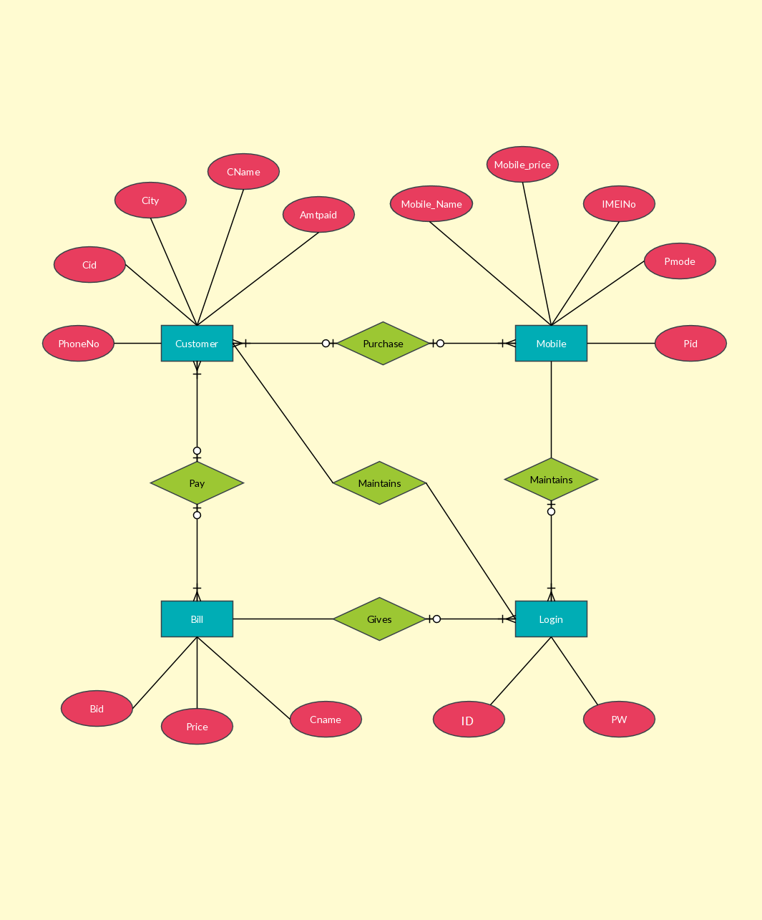

**Use Case Diagram:**

